**Staff Claims Reimbursement Guide**

This manual will guide CARES members on how to submit their expenses claims using CARES ERP system, Synergix. Before you do so, please read through the Expenses Reimbursement Policy which can be found on Employment Hero.

Where to access: Operations > Human Resources > Staff Claim > Processing > Staff Claim

1. Log in to Synergix. If you face any issues here, please speak to HR.

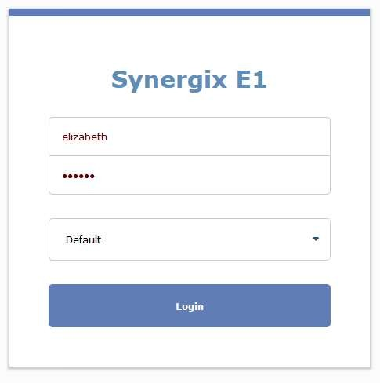

1. Go to operations, under Human Resource select Staff Claims.

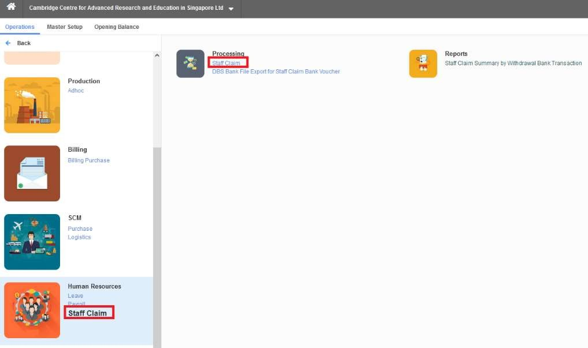

1. For new claims, please select ‘+’ icon.

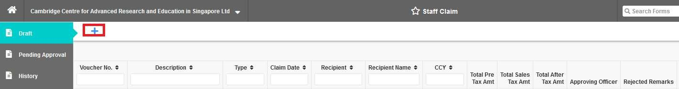

Note: Clicking the Magnifying glass button will give you a dropdown list of selection.

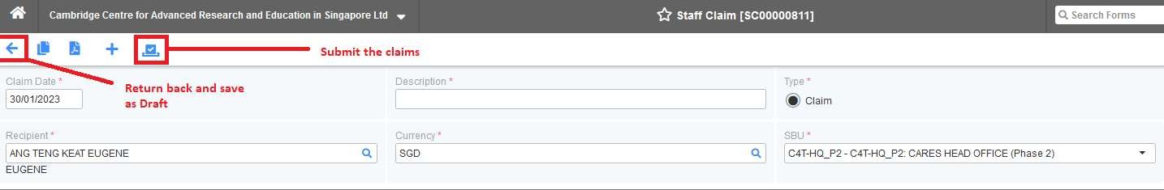

**Claim Date** – Generated by the system but can be amended. This is the date that you are submitting the claim, so you should use the date at which you submit this claim in Synergix.

**Description** – Brief description about what you are claiming (If this is travel related, kindly indicate Travel Location, Conference name and dates. An example will be ‘London_AGS Conference_27-30Dec’.

**Recipient** – The name of the person who paid for the expenses claim. This should be filled in automatically.

**Type** – Claim (No other selection)

**Currency** – Select the currency based on the receipts you are submitting. If your currency is not available in the system, kindly email the Finance team. You can also select SGD currency in the system for foreign currency receipts, kindly refer to [Claim amount determination] section below.

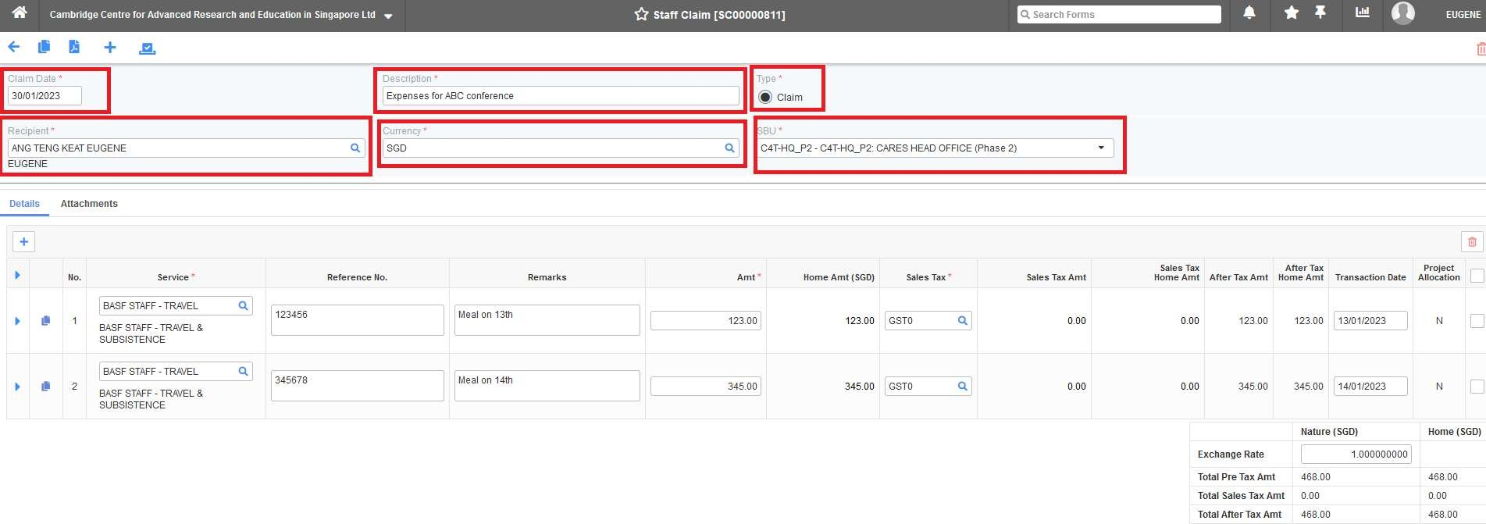**SBU** – Where this claim is going to be charged to (Usually this will be the project you are tagged under, if you have multiple projects then kindly look for the HR representative who booked your travel for you).

**IMPORTANT: Claim amount determination**

There are 3 ways to submit your expenses incurred in a foreign currency:

1. **Use the systems conversion** – this is the most straight forward way as all you have to do is select the currency (e.g. GBP) and enter the amount in GBP. The system will convert it to SGD for you and you will be reimbursed that amount in SGD. If you have both SGD and GBP receipts, please create 2 separate claims using SGD and GBP currency respectively. For this method, please stick receipts to an A4 sheet in order of date. Please use each page for only 1 date. Scan this and attach it to your staff claim.
2. [**OANDA**](https://www.oanda.com/currency-converter/en/?from=EUR&to=USD&amount=1) **conversion** – this can be time consuming for large number of receipts as you will have to use the conversion rate of the date of transaction from OANDA. On OANDA, type in the amount you spent in the original currency, and it will convert it to SGD. Please ensure you adjust the date, so it is from the date of transaction. Screenshot the SGD conversion and paste it to a document with the original receipt next to it. Please use an excel sheet to track the original receipt amount, and the OANDA conversion amount. We will need to see the excel sheet document, plus the receipt and OANDA screenshot on a PDF.
3. **Credit/Debit card statement** – you will have to match the receipt to the transaction on your card statement. This one gives you the most accurate SGD reimbursement but is also a tedious method. Like the previous way, we will need an excel sheet with a list of the original receipt amount, the credit/debit card amount. You will also need to attach the copy of the receipt, and the credit card statement and match them up.

**Details Tab**

To add extra expenditure line items under the same claim entry, click the plus sign 

**Service** – The correct service code / budget code (You can filter with your project code using the Magnifying Glass button and choose the appropriate one. Category usually is like Travel or Consumables, but when unclear you may look for Khatijah).

**Reference No** – The receipt or invoice number. Or if multiple receipts are under the same line item, you can put ‘multiple receipts’ and explain further in the remarks section.

**Remarks** – Short description for the specific entered receipts (**This cannot be left blank**, has to be the item description even if there is only one receipt).

**Amount** – Total amount for that particular expenditure line item .

**Sales Tax** – **Always** select GST0

**Transaction date** – The date that this transaction occurred

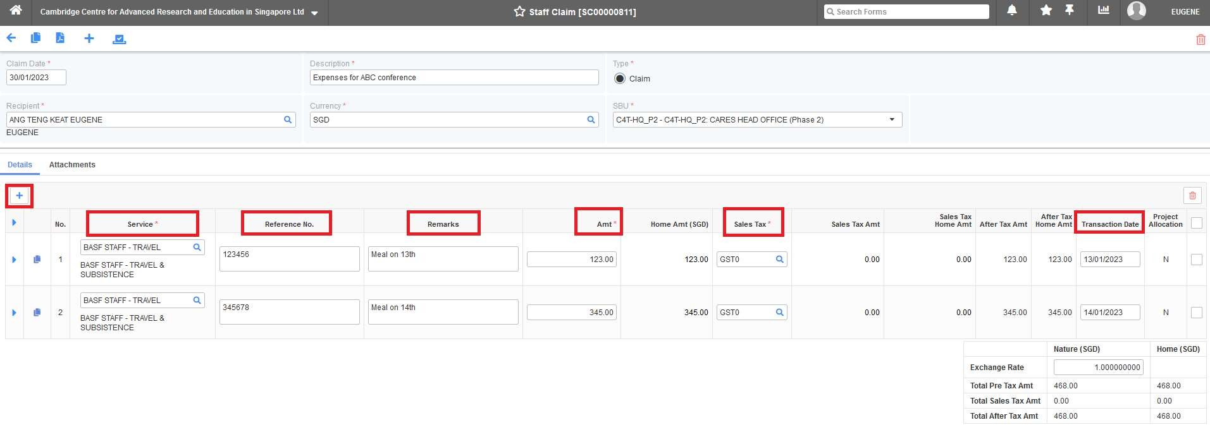

Enter each receipt / invoice that you are claiming. For each receipt, you will be asked to key in the service code. If you are claiming for the same category for multiple receipts, you can add them together and enter it as one entry (If using OANDA-rate method, please separate by date of receipt as new line item, unless you have an excel spreadsheet).

**Attachment Tab**

Claimant to upload all the receipts and supporting document. Leave a simple file description beside each attachment.

Points of note:

* Kindly avoid attaching receipts one-by-one as attachment, organize all receipts and invoices in PDF format (You can use websites such as [www.ilovepdf.com](http://www.ilovepdf.com) to convert into PDF or even merge PDFs together)
* Stick physical receipts by date order (1 side should only have receipts for that same date)
* Please do note that we are looking at the actual receipts and invoices (Which show the breakdown), and not the credit card slips (Credit card slips only mentions vendor name and amount that is paid). Kindly note the difference.
* You may find it useful to complete an excel sheet with a list of all the transactions for ease (especially useful if you have a load of receipts). You can attach this to the claim so it’s quicker for us to process.

**Submission & Approval**

Click to submit the staff claims after all details have been finalized. Once submitted, the Staff Claim Voucher will go to different level of verifiers and approvers:

1st Verifier: Admin

2nd Verifier: Finance Personnel 1st & 2nd Approver: Cambridge PIs

The system will inform Finance Personnel once the claim has been approved. Finance Personnel will then process the payment.

**To check the status of your claim**: Operations > Human Resources > Staff Claim > Processing > Staff Claim

Draft: Draft staff claims not submitted yet

Pending Approval: Submitted Staff Claims pending for verification or PI approvals History: Submitted and Approved Staff Claims

(Refer below screenshot on how to see the trail)

**Other point-of-notes:**

* Claims should be submitted within 3 months of expenditure, any later will be reimbursed at the discretion of CARES.
* Claims will be made by bank transfer to you within 4 weeks of submission.
* Claims will not be paid without documentary evidence.
* Hardcopy documents have to be kept minimally until the claim is approved in Synergix.
* For Flights or Accommodations, kindly refer to Financial Policy for more details. Kindly liaise with your HR representative in the event that you would like to book them by yourself, as there are procedures to follow and they will advise accordingly.
* General guidelines can also be found in the Financial Policy, if in doubt always check with HR personnel on what can be claimed.